|  |  |  |  |  |
| --- | --- | --- | --- | --- |
| **National University of Computer and Emerging Sciences, Lahore Campus** | | | | |
| C:\Users\saif\AppData\Local\Microsoft\Windows\Temporary Internet Files\Content.Word\final design.jpg | **Course Name:** | **Artificial Intelligence** | **Course Code:** | **AI2002** |
| **Program:** | **BS (CS) BS(DS)** | **Semester:** | **Spring 2023** |
| **Duration:** | **180 Minutes** | **Total Marks:** | **70** |
| **Paper Date:** | **22-May-2023** | **Weightage** | **45** |
| **Section:** | **ALL** | **Page(s):** | **10** |
| **Exam Type:** | **Final** |  |  |
| |  |  |  |  |  |  |  |  | | --- | --- | --- | --- | --- | --- | --- | --- | | **Question** | **Q1**  (CLO:2,3) | **Q2**  (CLO:3) | **Q3** (CLO:2) | **Q4**  (CLO:2) | **Q5** (CLO:2) | **Q6** (CLO:3) | **Total Marks** | | **Marks** | **10** | **15** | **10** | **10** | **15** | **10** | **70** | | **Obtained Marks** |  |  |  |  |  |  |  |   **Student Name: _____________________________ Section: __________ Roll No.________________** | | | | | |
| 1. Do not use pencil or red ink to answer the questions**.** In case of confusion or ambiguity make a reasonable assumption. *Attempt* ***all questions*** *on the question paper in space provided*. | | | | | |

**QUESTION 1:**

1. **(5)**

Draw a complete neural network that learns the following classification problem. Clearly state the activation function being used at each node. The input to the neural network should be the coordinates X1 and X2.

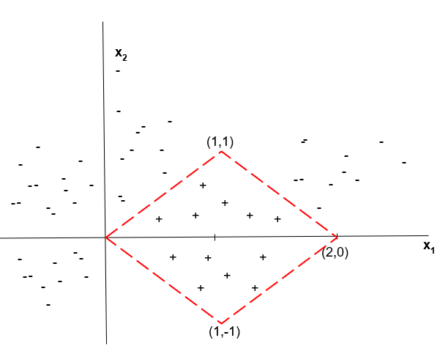**Note:**

The following have to be satisfied for a point to be classified as a positive example.

X1-X2 >0 AND

-X1+X2+2 > 0 AND

-X1-X2+2 > 0 AND

X1+X2 > 0 AND

1. **(2+3)**

A company wants to predict if their marketing campaigns will be successful based on various factors [ **Successful** (1), **Not successful** (0)]. They have collected data for multiple campaigns, including the campaign duration (in days), the number of social media ads, the number of email newsletters sent, the budget allocated for each campaign and number of employees assigned to each campaign.

They want to build a predictive model using a neural network to classify the output based on these features and automate the process by using a fully connected **feed-forward** **network**. The network has one hidden layer of 2 neurons and a single output neuron with linear activation function used in the hidden neurons and sigmoid activation used at the output neuron. The trained network weights for both campaigns are provided below:

|  |  |  |  |  |  |  |  |  |
| --- | --- | --- | --- | --- | --- | --- | --- | --- |
| **Hidden Neuron Weights** | | | | | | **Output Neuron Weights** | | |
| **H1** | **0.5** | **-0.2** | **0.5** | **0.5** | **-0.4** | **O1** | **1** | **1** |
| **H2** | **0** | **1** | **-1** | **0.3** | **-0.6** |

1. Assuming that the neurons DO NOT have bias terms, find if the following campaign will be successful given the campaign data: [5, -0.4, 0.8, -0.1, 0.3]
2. If the company wants to predict the rate of success, how can this problem be tailored to give you the rate of success?

**QUESTION 2:**  Consider the following map of Punjab cities with labeled distances in **km**. The problem is to find the path with the shortest distance from Faisalabad to Lahore city. The heuristic function ***hSLD*** straight-line distance from all cities to Lahore is provided in table below.

|  |  |  |  |  |  |  |  |  |  |  |  |  |  |  |  |  |  |  |  |  |  |  |  |  |  |  |  |  |  |  |  |
| --- | --- | --- | --- | --- | --- | --- | --- | --- | --- | --- | --- | --- | --- | --- | --- | --- | --- | --- | --- | --- | --- | --- | --- | --- | --- | --- | --- | --- | --- | --- | --- |
|  | |  |  | | --- | --- | | **Source Cities** | ***hSLD* to Lahore** | | Faisalabad | 160 | | Chiniot | 160 | | Gojra | 160 | | Jhumra | 150 | | Samundari | 145 | | Tandlianwala | 130 | | Sangla | 120 | | Pindi Bhattian | 110 | | Okara | 100 | | Renala | 90 | | Pattoki | 70 | | Shekhupura | 50 | | Firozwala | 10 | | Lahore | 0 | |

1. **(5)**

Apply the **Uniform Cost Search** to find the shortest path from Faisalabad to Lahore. Draw the state space search tree.

1. **(5)**

Perform the **Greedy Best first Search** to find the shortest path from Faisalabad to Lahore. Draw the state space search tree.

1. **(5)**

Apply **A* Search** to find the shortest path from Faisalabad to Lahore and build the search tree. Clearly indicate the order in which each state is expanded with open list (frontier) and closed list (visited nodes) updates.

**QUESTION 3: (10)**

Consider a game of Tic Tac Toe. **x** = Max, **o**=Min. Its max’s turn to play. Use minmax algorithm to find the optimum score and max’s next move? The current board position of the game is given below make the complete game tree from this configuration onwards.

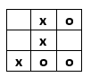

**QUESTION 4:**  Consider the house data provided in the table below, the price of a house with No. of Bedrooms and Area in square feet.

|  |  |  |  |  |  |  |  |  |  |
| --- | --- | --- | --- | --- | --- | --- | --- | --- | --- |
| No. of Bedrooms | 1 | 3 | 4 | 5 | 6 | 3 | 5 | 6 | 2 |
| Area | 60 | 120 | 200 | 200 | 250 | 80 | 250 | 200 | 80 |
| Price | 4000 | 6000 | 8000 | 9000 | 12000 | 6500 | 11000 | 10000 | 5000 |

* 1. **(7)**

Compute slopes and intercept to form the regression line equation.

* 1. **(3)**

Predict the price of a house having 7 bedrooms and 400 square yards of area.

**QUESTION 5:**

Consider the house data provided in the table below, the No. of Bedrooms and Area in square feet.

|  |  |  |  |  |  |  |  |
| --- | --- | --- | --- | --- | --- | --- | --- |
| **No. of Bedrooms** | 1 | 3 | 4 | 3 | 5 | 6 | 2 |
| **Area** | 60 | 120 | 200 | 80 | 250 | 200 | 80 |

1. **(5)**

Perform **k means** clustering on the above dataset with k=2. Consider the data points (1, 60) and (4, 200) as initial centroids. Show your working for the initial two iterations of the algorithm.

1. **(10)**

Apply Agglomerative clustering on the above data set with **Single link**. Show your working and create the dendrogram.

**QUESTION 6:**

1. **(3)**

A manufacturing company wants to optimize the production process of a particular product. The production process involves several parameters such as **temperature**, **pressure**, and **duration**. The company wants to find the optimal combination of these parameters that maximizes the yield of high-quality products. Your task is to apply a genetic algorithm to solve this optimization problem.

Design a chromosome for the above problem. What encoding scheme will you use?

1. **(3)**

In Genetic algorithm if we use only crossover and not mutation then does it make any hurdle in finding our desired solution or not? Give reason to support your answer?

1. **(4)**

Differentiate forward and backward chaining in expert system with an example.

**Rough Work**